A CRM APPLICATION FOR THECHAISHOP&CO
2. Requirement Analysis Phase

Project & Team Details
Attribute | Details
Project Title | A CRM Application for TheChaiShop&Co
Domain | Cloud Computing / Salesforce Administration
Platform | Salesforce Lightning Developer Edition
Institution | PS PT MGR Government Arts & Science College, Sirkali, Puthur - 609108 (College Code: ANM403)
Submission Portal | SkillWallet
Team Leader | PRITHIVIRAJ R - (Reg. No. 24134031802521033)
Member 2 | Dharun Mass - (Reg. No. 24134031802521016)
Member 3 | Ajan A - (Reg. No. 24134031802521006)
Member 4 | Sanjai D - (Reg. No. 24134031802521041)
Member 5 | Vigneswaran C - (Reg. No. 24134031802521055)

User Story
As a sales representative at TheChaiShop&Co, I want to efficiently manage customer relationships and streamline sales processes using our CRM application. I want to easily access and update employer details, as well as distinguish between online and offline customer records using record types, allowing for personalized interactions. Additionally, I need the application to automate sales calculations, such as order quantity and total bill amount, to ensure accurate and efficient transactions. Moreover, I require the ability to generate insightful reports and dashboards to summarize and analyze sales data effectively, aiding in decision-making and strategy development. Lastly, I would like the application to automate email notifications to customers on their birthdays, informing them of special offers tailored to celebrate their special day, enhancing customer engagement and loyalty.

3. REQUIREMENT ANALYSIS PHASE

3.1 Customer Journey Map
The customer and user transaction journey consists of seven distinct stages:
- Login: Authenticate securely into the Salesforce Developer Edition environment.
- Access CRM Application: Open the "TheChaiShop&Co" custom application from the App Launcher.
- Enter Customer Data: Capture customer demographic and contact details.
- Generate Orders: Select items and categorize order types (Online vs. Walk-In).
- Calculate Bills: System automatically computes order volumes and gross bill amounts using formula logic.
- View Reports: Review summarized sales data categorized across channels.
- Decision Making: Analyze executive dashboards to identify sales trends and adjust inventory.

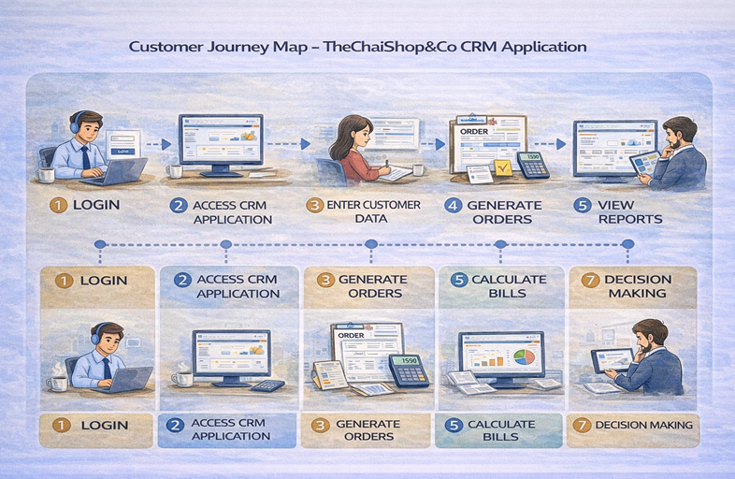

3.2 Solution Requirements
A. Functional Requirements (FR)
FR No | Requirement Name | Description
FR-1 | User Login | Allows authorized users to securely log in to the CRM system using valid credentials.
FR-2 | Object Creation | Custom schema architecture to store Customer, Employer, and Enterprise account records.
FR-3 | Data Entry | Dynamic data entry with record types and page layouts for Online and Walk-In customers.
FR-4 | Billing Automation | Automatically computes order volume and total bill amount using formula fields.
FR-5 | Report Generation | Generates detailed tabular and summary reports on sales and customer performance.
FR-6 | Email Automation | Sends automated birthday greetings and discount codes via schedule-triggered flows.

B. Non-Functional Requirements (NFR)
NFR-1: Usability
- Simple and intuitive user interface with clear navigation menus.
- Counter staff can log in, enter customer details, and generate orders within a few minutes without technical training.
NFR-2: Security
- Role-based access control, secure authentication, and field-level security.
- Protects customer and business transaction data from unauthorized access.
NFR-3: Reliability
- Automatic data saving and transactional recovery within the Salesforce Cloud environment.
- Consistent system performance with zero data loss.
NFR-4: Performance
- Fast page loading and quick report generation within 2 to 3 seconds.
- Smooth dashboard rendering even with high transaction volumes.
NFR-5: Availability
- 24/7 cloud system availability with minimal operational downtime.
- Uninterrupted access during peak counter hours and holidays.
NFR-6: Scalability
- Multi-tenant infrastructure easily supports increasing customer data, transaction records, and multi-branch retail expansions without degradation.

3.3 Data Flow Diagram (DFD)
The overall data flow within the system is represented as:

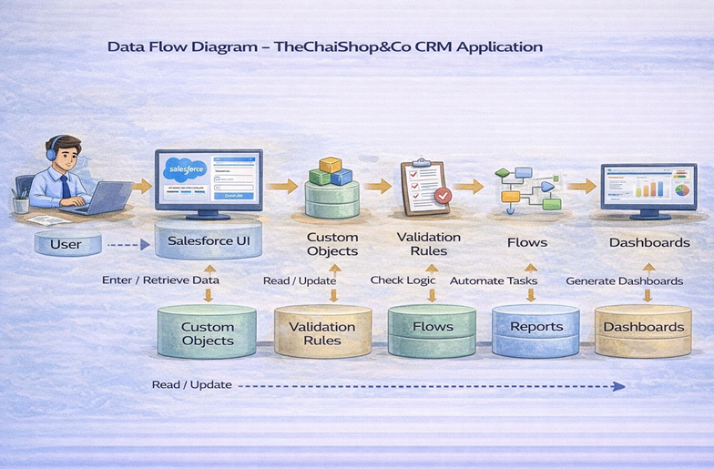

3.4 Technology Stack
Layer | Technology Component | Description
Frontend / UI Layer | Salesforce Lightning Experience | Responsive modern user interface, App Launcher, and navigation tabs.
Database Layer | Salesforce Cloud Platform | Relational data persistence using Custom Objects and Lookup relationships.
Business Logic Layer | Declarative Formulas & Validation Rules | Real-time billing calculations and data formatting rules.
Automation Layer | Schedule-Triggered Flows & Email Alerts | Automated daily scans and personalized customer birthday email alerts.
Analytics Layer | Reports & Dashboards Engine | Summary metrics, grouped sales reports, donut charts, and horizontal bar charts.

